**PRACTICAL NO 8**

**AIM:**Practical of Clustering

df=read.csv("C:/TYCS A-11/AGE.csv")

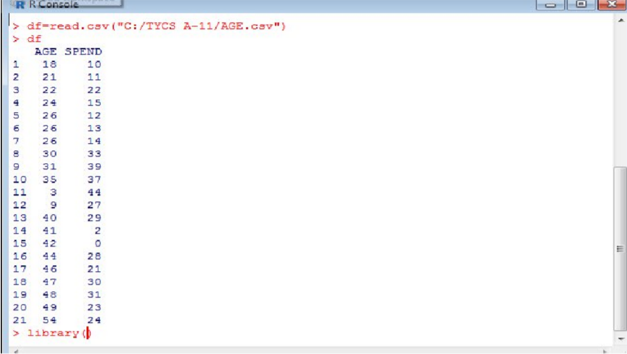

#plot(df)

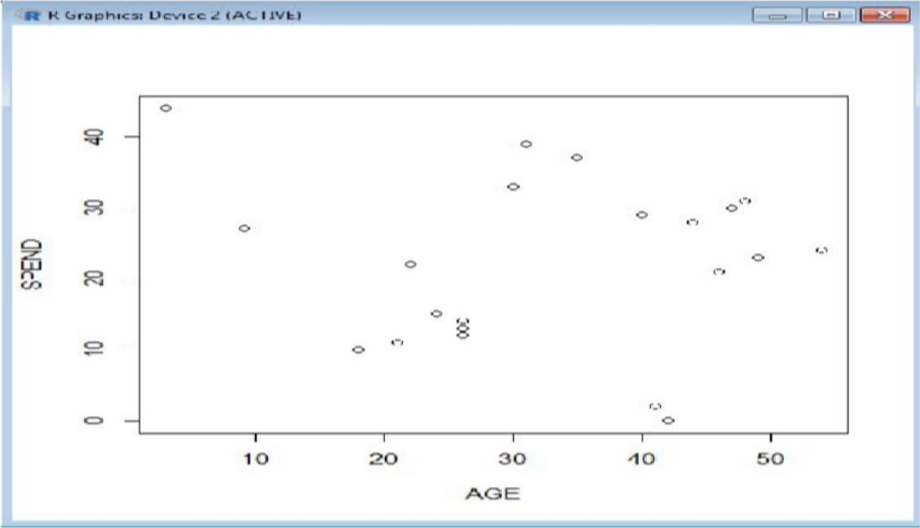

#boxplot(df)

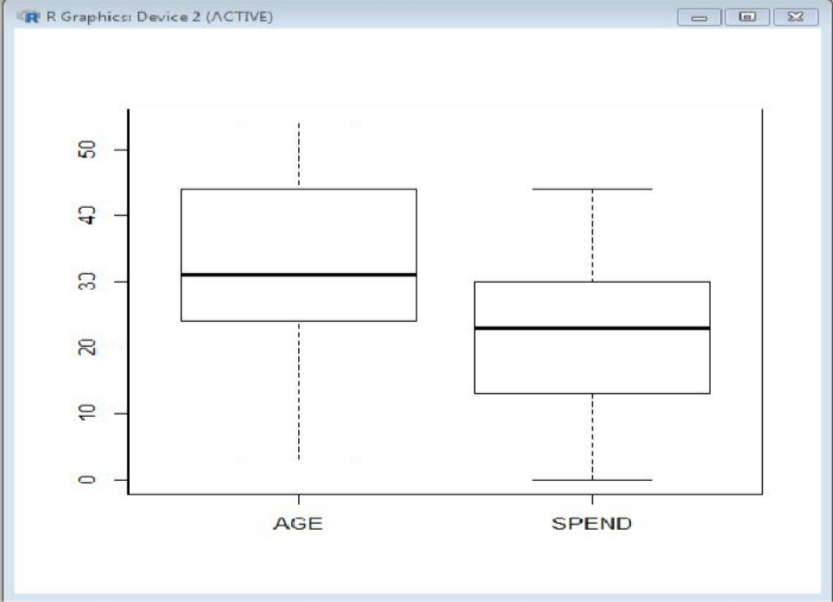

### Make the cluster

>set.seed(20)

* c1=kmeans(df[,1:2],3)
* c1

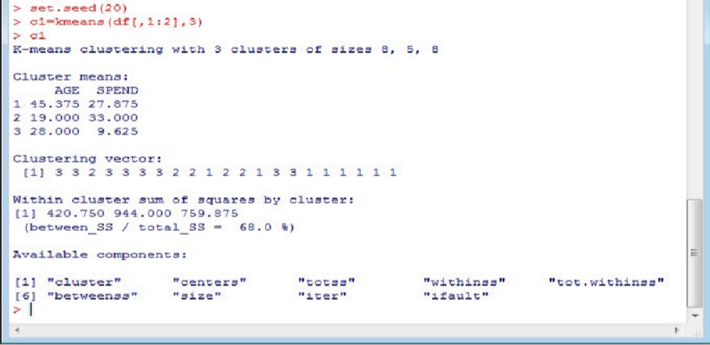

**#SHOW THE IRIS DATA SET**

>iris

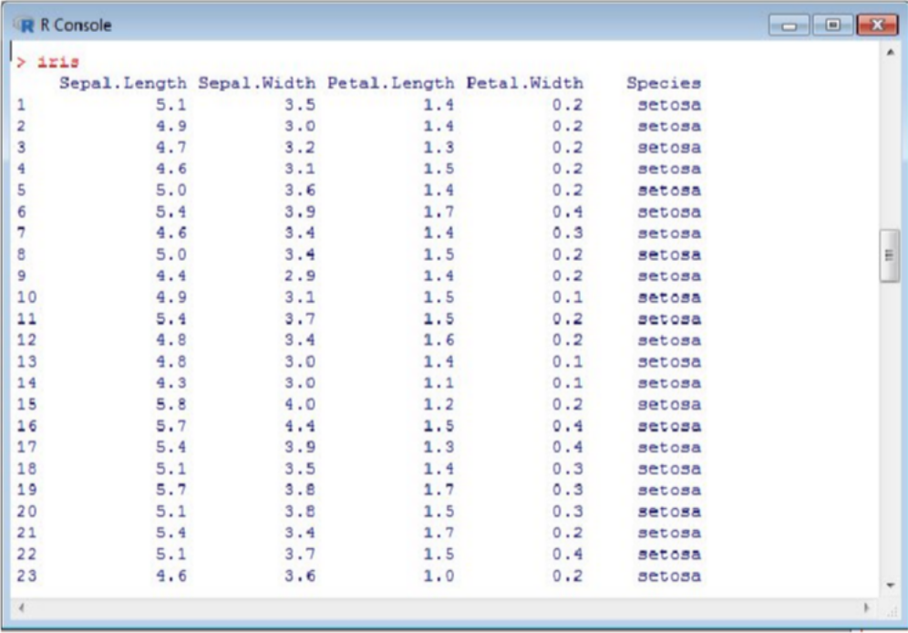

#View(iris)

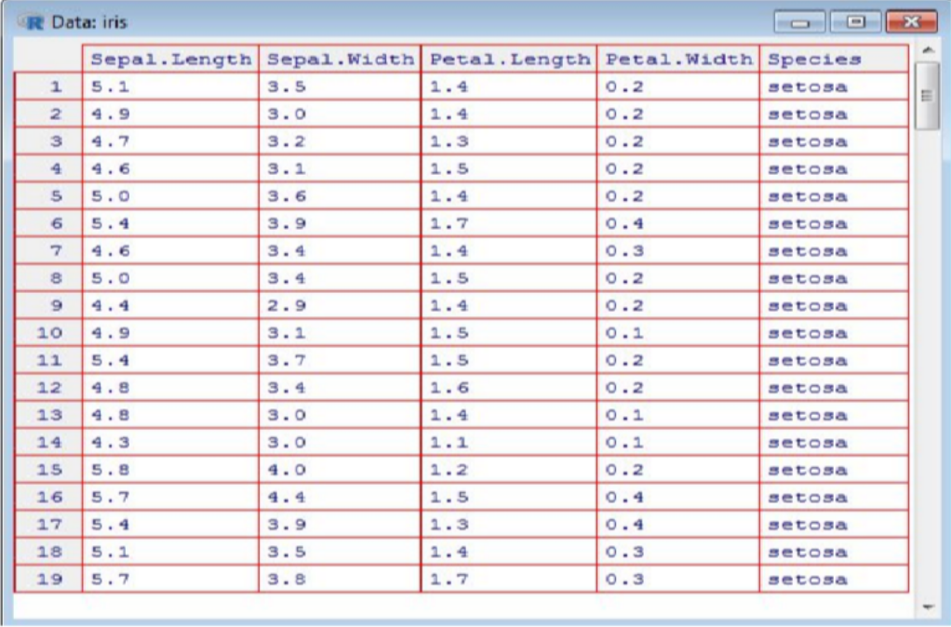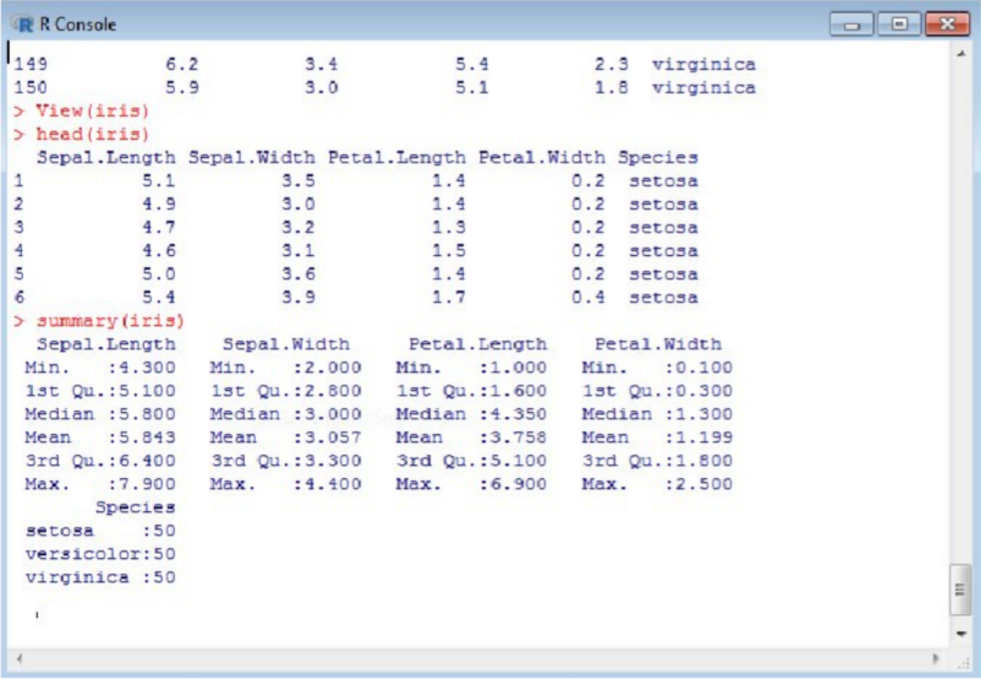

>plot(iris)

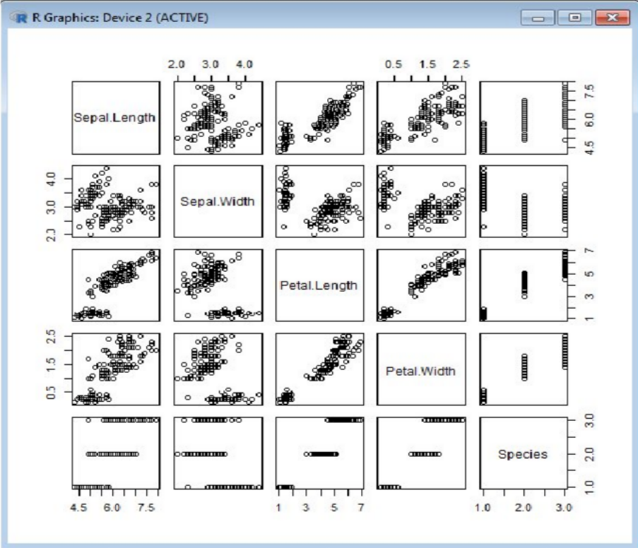

>plot(iris[,3:4])

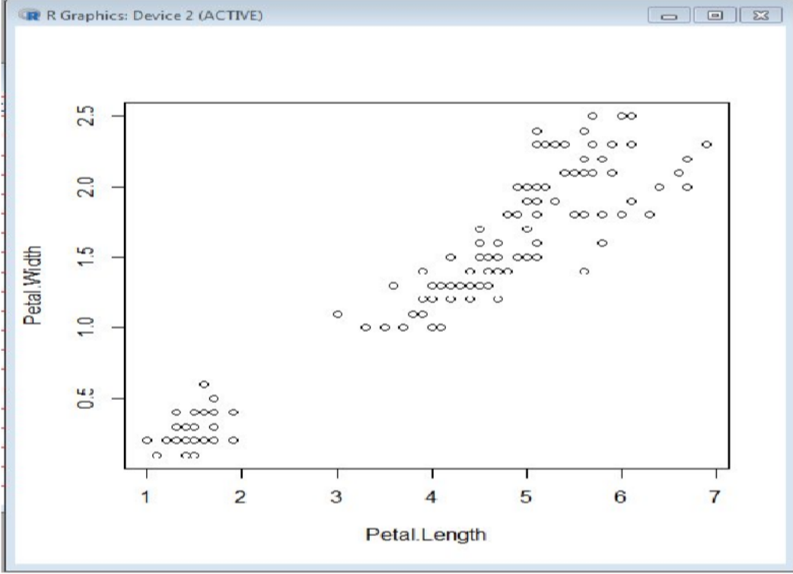

* kmeansc1=kmeans(iris[,3:4],3)
* kmeansc1

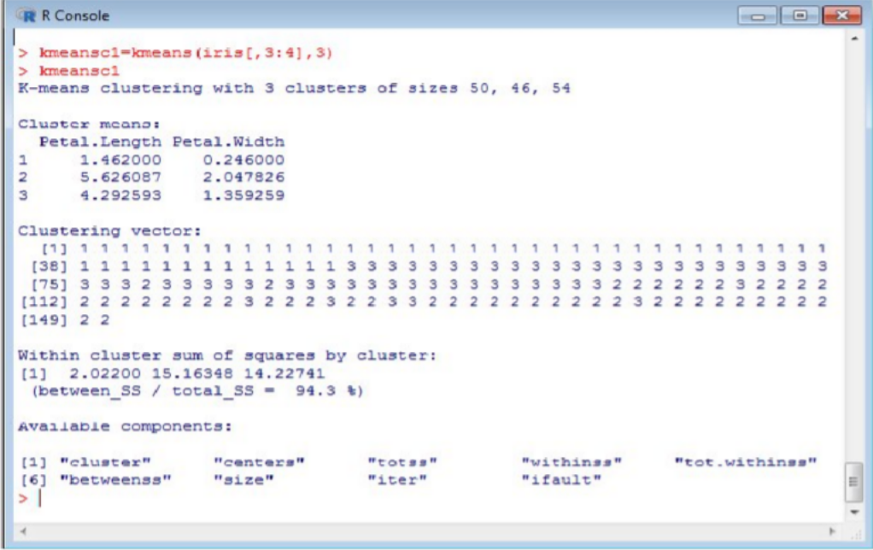

### PRINT CONFUSION MATRIX

>table(kmeansc1$cluster,iris$Species)

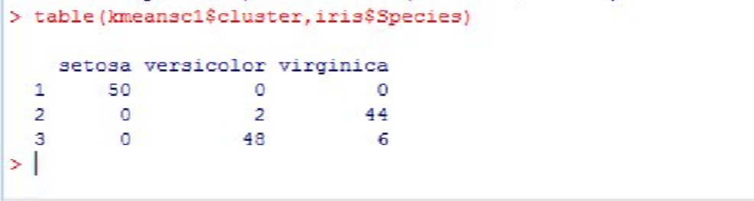

CALCULATION OF ACCURACY 94.6%

>boxplot(iris)

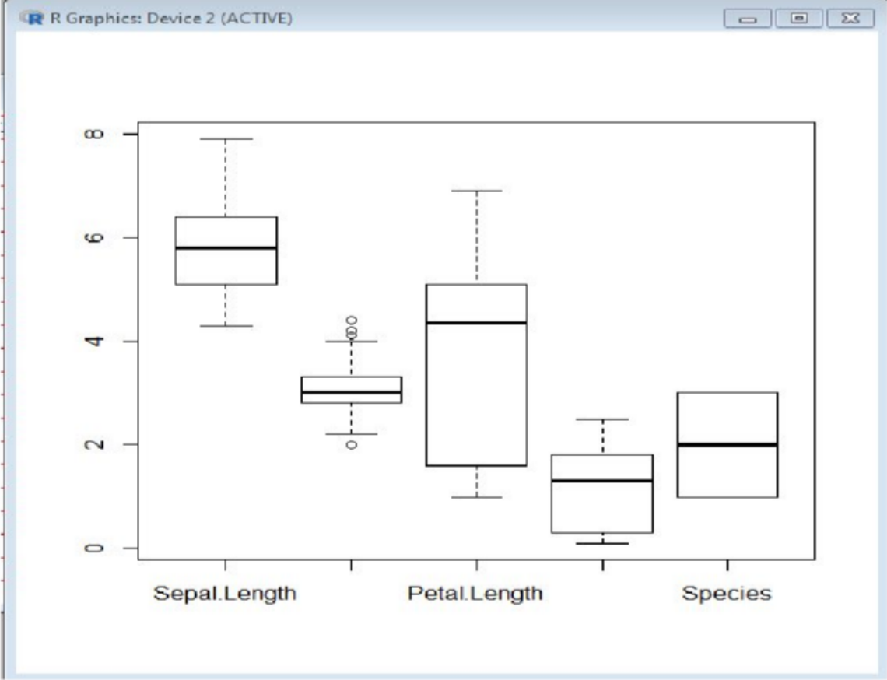

**CONCLUSION:**Thus we have implemented Clustering successfully.